**STUDENT PROGRAM LEARNING PLAN**

**Oh the Places You’ ll Go -- At the Airport**

Note: The model Learning Plan below is an exemplar. It includes various tasks in the three modes of communication as a reference for STARTALK Program Directors, Lead Instructors, and teachers as they plan lessons and learning episodes. These plans are not meant to be followed exactly because every program is different. Instead, they are meant to give ideas on how learning plans might be implemented. **These plans include more detail than is required.** STARTALK encourages comprehensive plans but does not require the level of detail included here.

*For step-by-step help in completing this document, please see the accompanying* [*annotated learning plan*](https://startalk.umd.edu/public/system/files/resources/studentprogramannotatedlearningplan.pdf) *and sample learning plans.*

|  |  |
| --- | --- |
| **Date:** | **Grade Range of Learners:** 6-8 **Targeted Performance Level: NH** |
| **Time Allotted for This Learning Plan: 90 minutes** | |

|  |
| --- |
| **Lesson Can-Do Statements**  *Identify specific Lesson Can-Do statement(s) from the Program Can-Do statements in the Curriculum Template (column 2) that are appropriate for and specific to this learning plan.* |

|  |
| --- |
| Interpersonal Speaking:   * I can exchange greetings with people I meet on my trip using culturally appropriate, memorized phrases and appropriate cultural gestures. * I can say that I am happy to meet someone. * I can greet others using appropriate phrases and gestures. * I can ask and answer a few personal identity questions with the customs officer such as name, age, place of birth, destination, and reason for travel. * I can exchange some personal information with fellow travelers and airport personnel.   Interpretive Listening:   * *I* can recognize and understand basic information conveyed by words, phrases, and sentences that I have memorized. * I can understand simple questions or statements about familiar topics. * I can understand questions asked by customs officesr and fellow travelers.   Presentational Speaking:   * I can state my name, age, birthday, where I live, and my travel destination. * I can greet fellow travelers, the customs officer, and other people I meet at the airport. * I can describe where I was born. * I can state my birthday. * I can talk about my travel destination. * I can state that I am traveling to the target country as a tourist. |

*Indicate what learners need to know and understand to meet the Lesson Can-Do statements above.*

|  |  |  |  |  |  |
| --- | --- | --- | --- | --- | --- |
| **Culture** |  | | **Content** |  | **Language** |
| Greetings  Honorific titles  Appropriate register  Personal space  Cultural gestures | |  | | Hello/Goodbye How are you?  Fine/So so/ Nice to meet you.  What’s your name? My name is…  Where were you born?  I was born in …  Where are you going?  I am going to…  What is your reason for travel?  I am sightseeing. | |

**EPISODE # 1 Number of minutes****for this episode:** 45

|  |  |
| --- | --- |
| **STAGE 1**  **Lesson Can-Do Statement(s) Addressed:** *See box above* | **STAGE 2**  **Check for Learning**  *Task or activity learners will do to provide evidence that they are making progress toward the Lesson Can-Do statement(s).* |
| I can tell my birth date, place of birth, travel destination, and reason for travel. | Using masks depicting people with various roles, students mingle in the classroom to greet one another, ask each other’s names, and share some personal information about their trip. Students exchange masks and continue the introductions. |

**STAGE 3 Enabling Activities**

*Tasks that lead learners to demonstrate what they can do with what they know.*

*There is a large map of the target country posted on the classroom wall and a visual of a passport from the target country.*

1. The teacher enters the classroom dressed as a traveler with a suitcase, a camera, a phone, and an umbrella. Using props and pictures, and maps, the teacher introduces him/herself to the class and gives some personal information such name, where he/she lives, the destination that he/she will be visiting. Teaching Assistant then introduces him/herself giving the same information as the teacher. *I Do*
2. Next, the teacher projects pictures of a variety of people students might meet during their travels to the target country. Students greet them saying hello and asking their names, where they live (adult traveler, teen traveler, adult from the target country, airport officer)*. I Do*
3. Teacher and students practice greeting different people they might meet at the airport using **Chat Stations**. (Chat Stations are discussion prompts that students go to just like learning stations. At the chat station there are discussion prompts that students must talk about. These prompts can vary from the simple to complex.)

The teacher posts large visuals and sentence and question frames at each chat station. For example, at the first station, students take the roles of an American teenager and teenager from the target country. They greet and talk with one another using informal register and exchange personal information such as where they live and where they are going.

At the second chat station, they take the roles of an adult and a teenager who meet at the airport. They greet one another and exchange personal information with an adult. Students use the posters at each station as needed when interacting with one another.

At the third chat station, students take the role of traveler and an airport officer. They meet and greet one another. The officer asks the traveler his/her name, place of birth, and destination and the teenager responds.

Students change partners and rotate through the chat stations a second and third time for additional practice.

*We Do Guided*

1. Teacher distributes masks of people students might meet at the airport and during their travels in the target country. On the teacher’s signal, students mingle in the classroom to greet one another, ask each other their names, and share some personal information. Students exchange masks and continue the introductions. *You* *Do*
2. To debrief the task, the teacher calls a few pairs of students to choose masks and enact the scenario at the airport in front of their classmates . *You Do*

|  |
| --- |
| **Differentiation Strategies**  *Adjustments to instruction or activities to meet learner needs based on age, readiness, process, or output.* |
| The teacher provides question and answer frames and visuals at chat stations to guide students to carry out the brief interactions with peers using appropriate language and cultural gestures. |

**EPISODE # 2 Number of minutes****for this episode:** 45

|  |  |
| --- | --- |
| **STAGE 1**  **Lesson Can-Do Statement(s) Addressed:** *See box above* | **STAGE 2**  **Check for Learning**  *Task or activity learners will do to provide evidence that they are making progress toward the Lesson Can-Do statement(s).* |
| I can interact with the customs officer at the airport upon arrival in the target country. | Choosing a passport and adopting the role of a traveler or a customs officer, students enact the scene of asking and answering questions at customs in the target country. |

**STAGE 3 Enabling Activities**

*Tasks that lead learners to demonstrate what they can do with what they know.*

1. Teacher introduces a scenario to the class. Example: *Your travel group has arrived at the airport and you must navigate customs with your passport.* Teacher projects a sample page from a passport issued by the target country and talks aloud about the information on the document. *I Do*
2. Teacher and assistant take the roles of the customs officer and traveler to enact the scenario while students watch and listen. I Do
3. Teacher models the scenario with a strong student while the class observes. *We Do Guided*
4. Teacher guides 2 students as they enact the scenario taking the roles of customs officer and traveler. *We Do Guided*
5. If needed, the teacher engages students in additional activities to practice stating birth dates and reasons for travel to the target country.

Students make name cards following a sample provided by the teacher. They put their first and last names in the center of a large index card. In the right top corner, they put the month they were born. In the left ,top corner, they write the number of the day they were born, in the right bottom corner, they put the city where they were born, and in the left bottom corner, they put their reason for traveling to the target country (sightseeing).

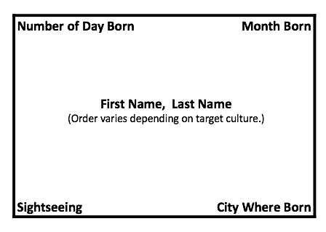

They circulate with the name cards to exchange information with classmates. This provides meaningful practice while recycling previously learned content. *We Do Guided*

1. Students choose a passport from a group of sample passports prepared or gathered by the teacher. They choose a role card from a bag or box. The card indicates whether they will play the role of the customs officer or traveler. They enact the scene with a partner. On the teacher’s signal, they choose a different partner, role, and passport and reenact the scenario a second time. *You Do*
2. Students complete an exit ticket giving one new learning and one question they still have about the process followed at the airport. *You Do*

|  |
| --- |
| **Differentiation Strategies**  *Adjustments to instruction or activities to meet learner needs based on age, readiness, process, or output.* |
| The teacher provides sentence starters and sentence frames to help some students with the role play. |

|  |
| --- |
| **MATERIALS NEEDED**  *What supplies and materials will you need to successfully implement this learning plan?* |
| Large map of target country and passport from target country  Items a traveler would need: suitcase, umbrella, camera, phone, passport  Sample passports  Boarding pass and passport for students ( optional)  Pictures of variety of people students might meet on the trip  Masks -- a picture or drawing of a person attached to a wooden stick. Students hold it up in front of their faces for role plays  Name cards, Role Cards |

|  |
| --- |
| **PERSONAL REFLECTION**  *How did this lesson go? What could you do to improve this learning plan if you do these activities again?* |
|  |

**Another element that could be added to the unit:**

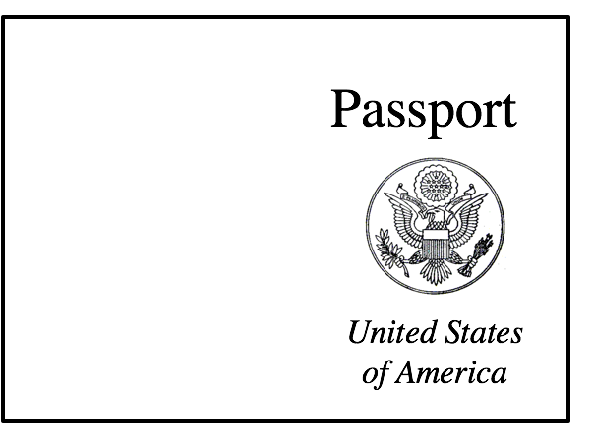 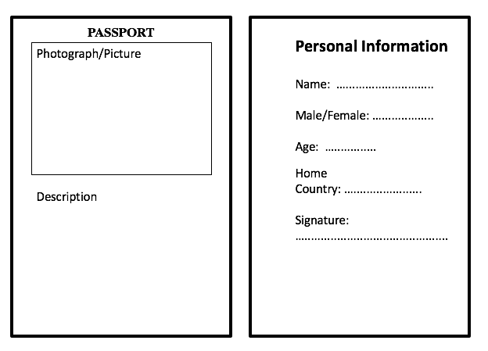

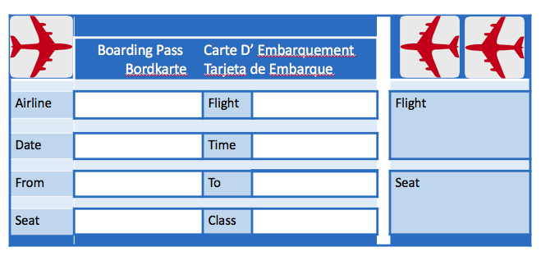

**Please Note: The language items in these learning plans will need to be recycled throughout the program.**